1. Get an SVG editor (adobe illustrator..) free solution : <https://editor.method.ac/>
2. Specify the models you need to make (2 genders , 4 ages [adult , child , toddler,infant] , 2 positions( front, back ) )
3. Create the outline of the patient model (make sure to make fillable gaps so you can change the edges colours anytime)

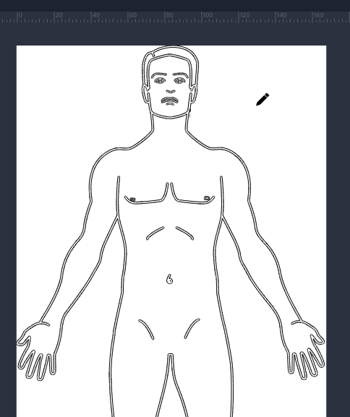

This part will be in its own group (<g> tag) so it can be styled as a whole

1. Create multiple paths to specify each area of the body. Each part will have it’s own path so it’s possible to add a :hover style to it

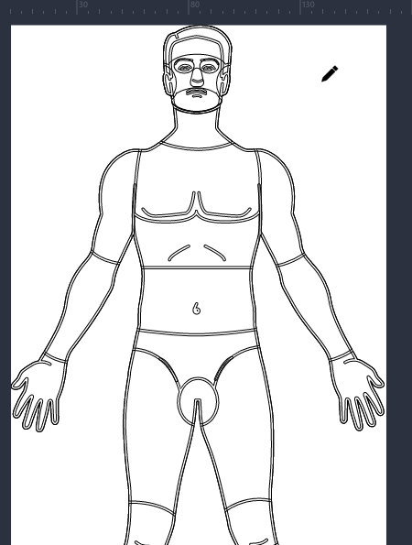

1. Export the SVG

Inspiration: https://symptomate.com/fr/diagnosis/